San Jose State University

EE250 (Section 2) Fall 2019 Prof. Kamali

Problem Set #6

- Problem 5.98
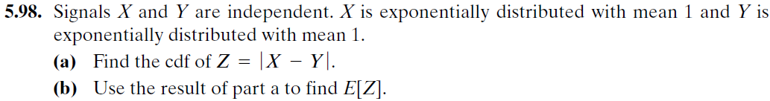

- Problem 5.106

- [Midterm, Spring 2014] The joint pdf of the random pair 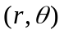is given as follows.

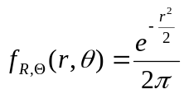 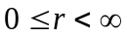,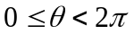

Find the probability that lies in the following region.

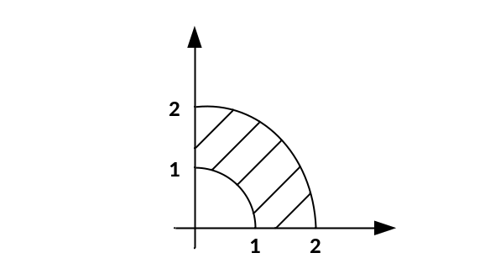

- [Midterm, Fall 2014] Suppose 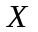 and 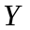are two independent uniform random variables between [0,1]. Find the pdf of 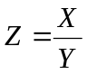.

- [Midterm, Spring 2015] The joint pdf of the random pair 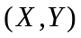 is given as follows.

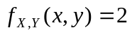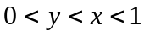

Find the pdf of 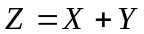.

- [Final, Spring 2015] The joint pmf of the discrete random pair is given in the following table. Find 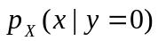.

 | 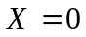 | 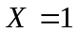 | 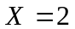
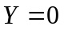 |  | 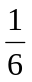
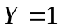 |  |  | 0
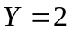 |  | 0 | 0

- [Final, Spring 2017] The joint pmf of the discrete random pair 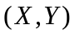 is given in the following table. Find 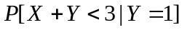.

 | 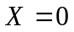 |  | 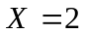 | 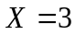
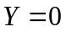 | 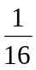 |  | 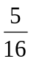 | 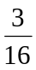
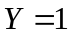 | 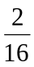 | 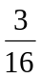

- [Midterm, Summer 2008] Supposeand are two independent uniform random variables between and and 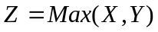.

- Find 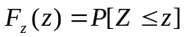.
- Find 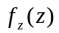(pdf of 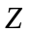).

- [Midterm, Fall 2008] The joint pdf of the random pair is defined as follows.

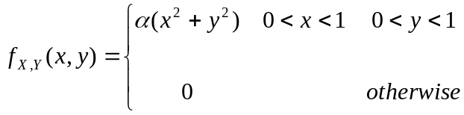

- Find .
- Find 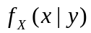.
- Find 

